Controlling the XPOL Radar

# Starting the Radar

When starting the radar, you will need windows open on both the “xpol” and the “drx” computers, both logged in as “radarop”. These windows should have access to your local X server (so use the “-X” option on your ssh command). You must go through “xpol” to get to “drx”. You can just type drx in your “xpol” window to get to “drx”.

The “drx” computer runs the server that controls the radar and acquires the data. We run applications on “xpol” that contact this server.

Before starting DRX, make sure that the processes on “xpol” are stopped. You can do this by running the following command in the “xpol” window:

stop_all

## Starting up the DRX server

To start up the basic system on “drx”, run the following command:

start_all

The main application running on “drx” is called “xpold”.

## Starting the Radar

The radar software comes with a GUI for controlling the radar. To start the GUI, run the following command on “drx”:

start_xpol_control

It is okay for several versions of the GUI to be running simultaneously, but could be confusing if two people are sending controls to the radar at the same time, so we will ask you to turn the GUI off once the radar is running. You may want to resize the GUI window to get rid of any scrollbars once it comes up. Here is what the GUI looks like when you first bring it up:

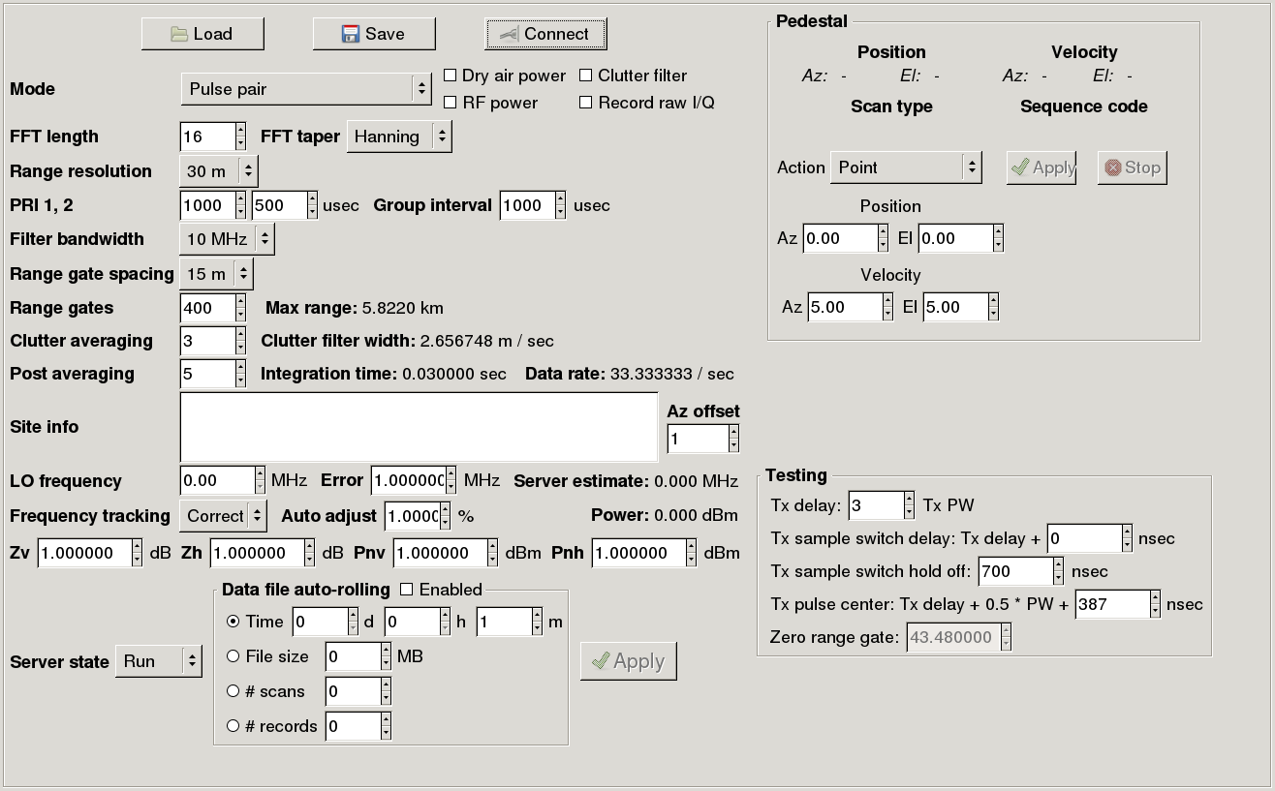

## Connect to the xpold server

To connect to the xpold server, click the “Connect” button at the top of the window:



Once you are connected to the radar, the label for this button will change to “Disconnect”:

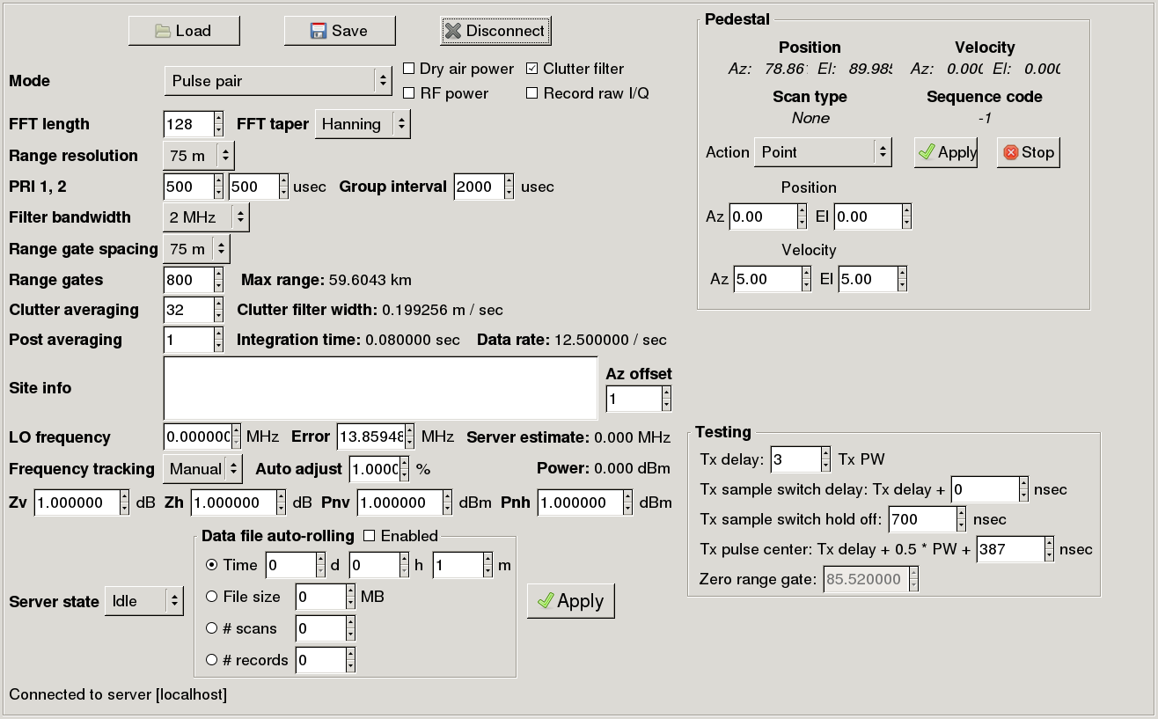

## Make sure the server is in run mode

The current server state is displayed in the lower left-hand side of the GUI:



To change the server state to run, click in the “Server state” choice box and select “Run”. Then click the “Apply” button in the center bottom of the window:

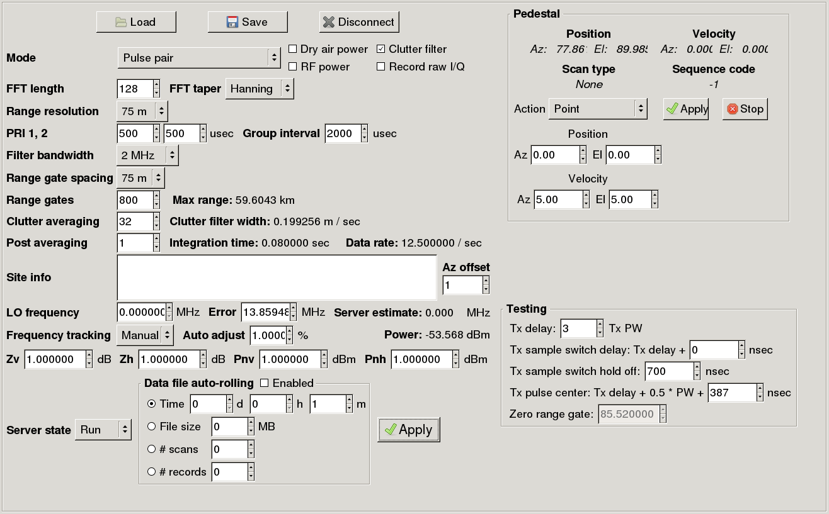

After clicking the “Apply” button, you will see some messages in the status area in the lower left-hand corner of the display indicating what the server is doing:



You must wait until the status area clears before making any more changes to the GUI. This is true whenever you click this “Apply” button.

## Point the antenna vertically

Make sure the antenna is pointed vertically up, so there is no radiation hazard. This is done in the “Pedestal” section. Set the indicated values in this section and then click the “Apply” button in that area:

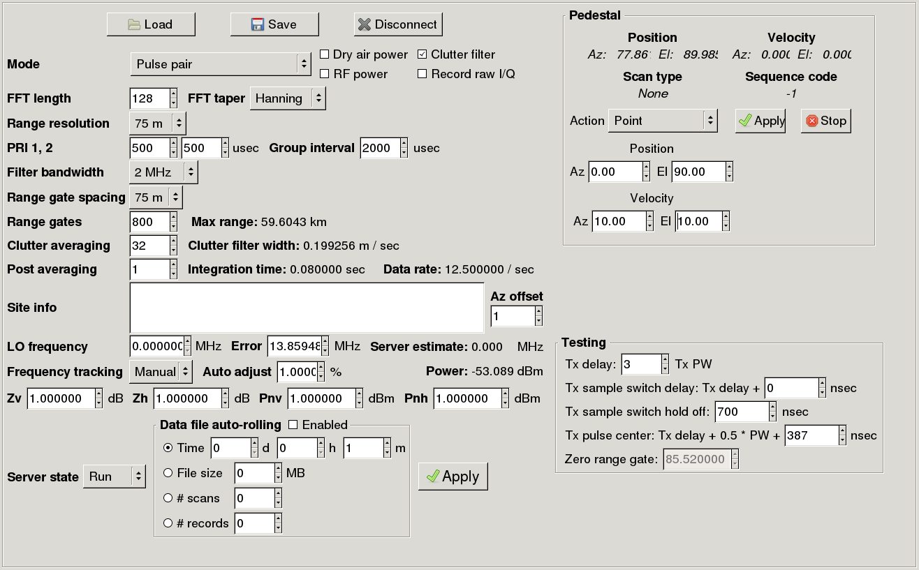

Wait until the elevation is close to 90 degrees, i.e. the antenna is pointing vertically, before proceeding:

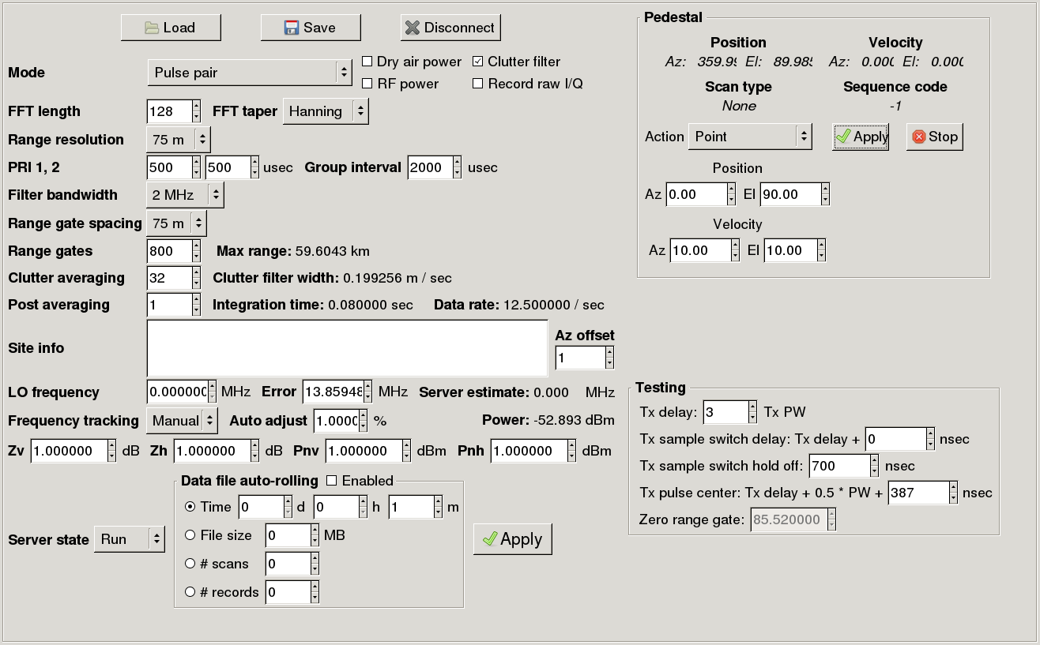

Once the antenna is pointing vertically, click “Stop” to set the brakes:



## Turn on dry air power

Next you should turn on the dry air power to keep the antenna ventilated. To do this, click on “Dry air power” to get a check mark and then click “Apply”:

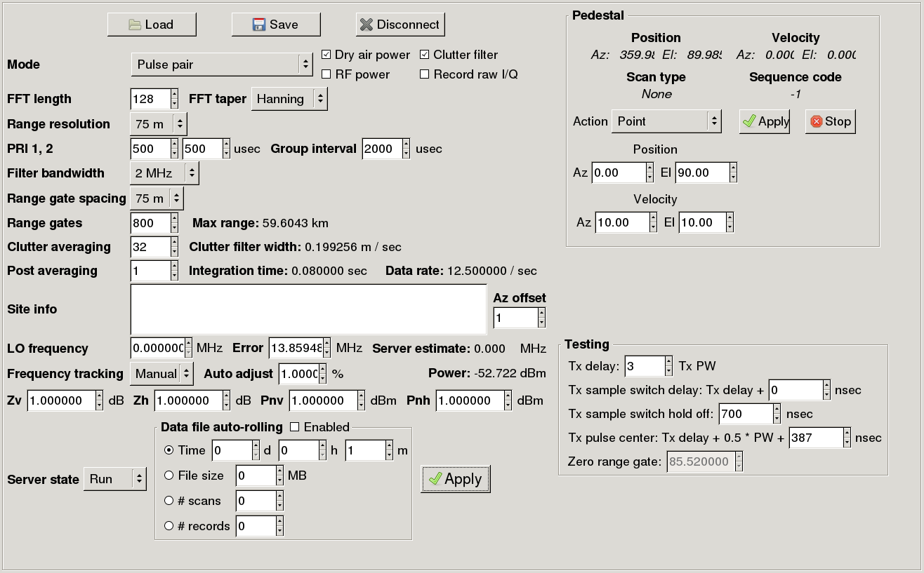

## Turn on the transmitter

Now it’s time to turn on the transmitter. First, click on “RF power” to get a check mark, set “Frequency tracking” to “Manual” and click “Apply”:

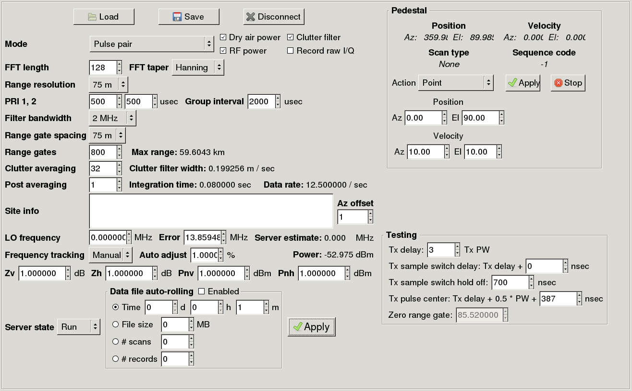

Then, set “LO Frequency” to 17.0 and click “Apply”:

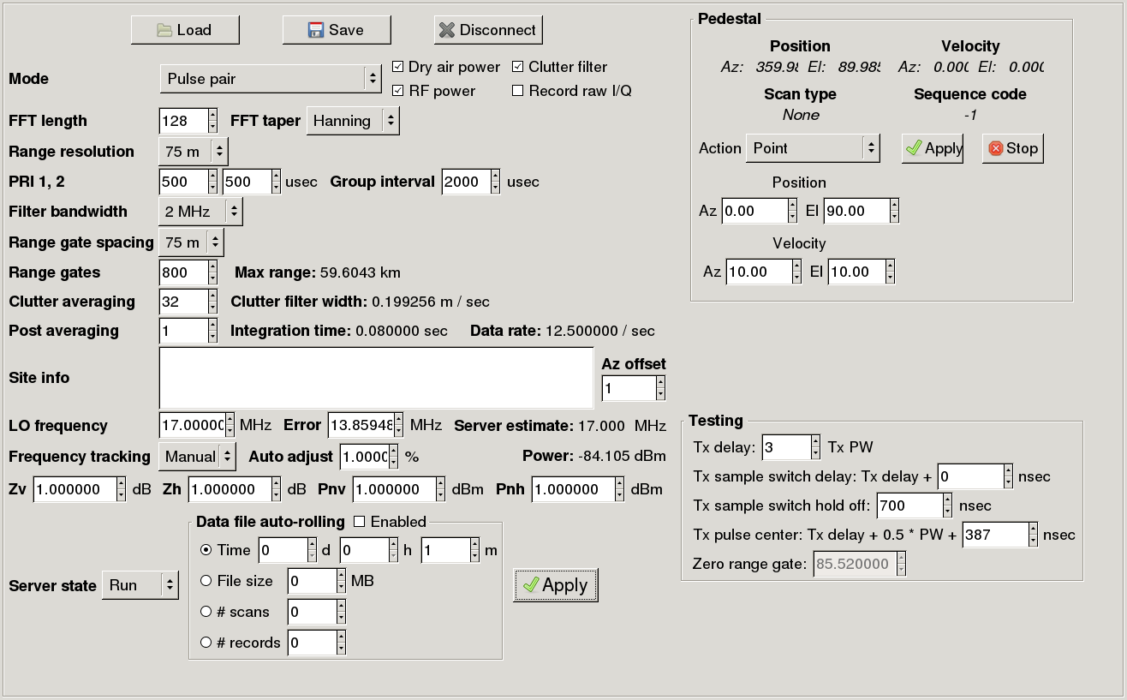

You must put the frequency tracking into manual mode before setting the frequency value or the GUI will ignore the value that you enter.

Monitor the “Power:” value. This starts around -85 dBm or nan. The power should increase to around -12 dBm. This can take a few minutes as the transmitter warms up.

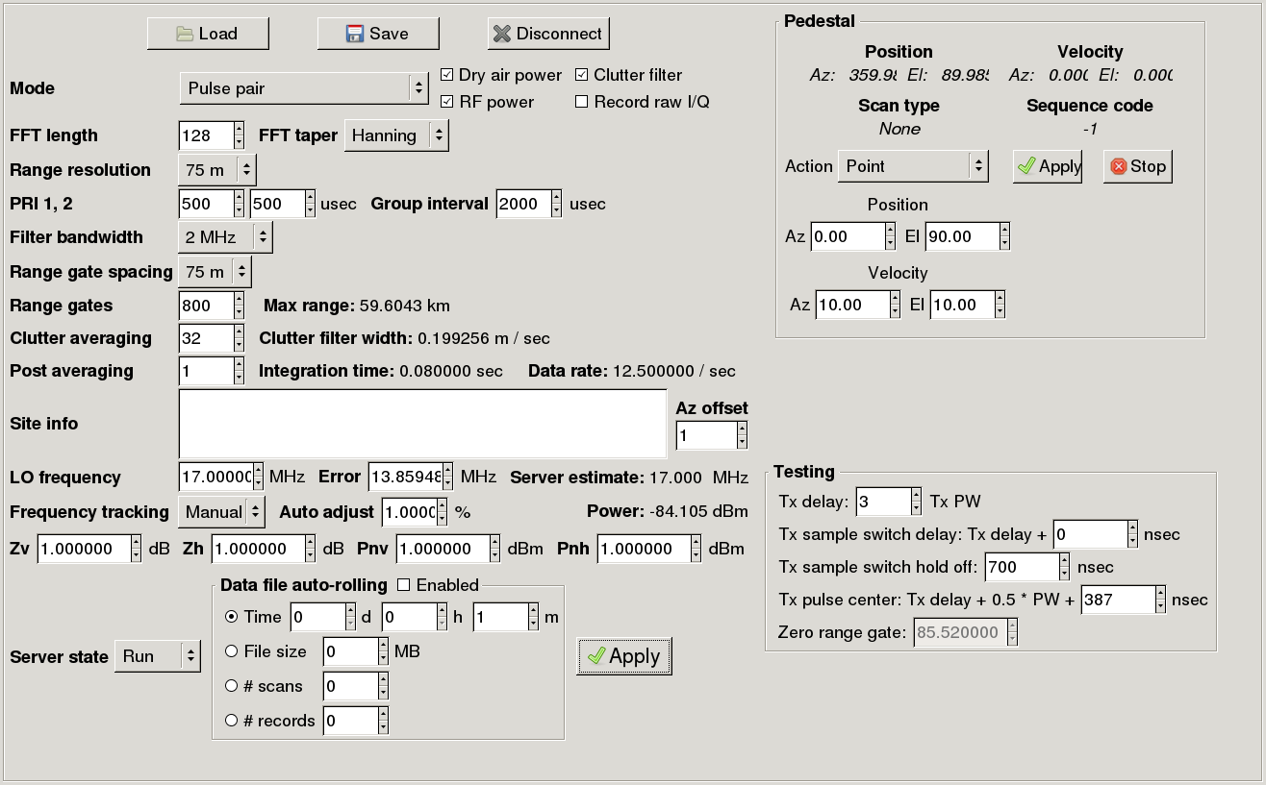

Once the power value is around -12, set the values as indicated below and click “Apply”:

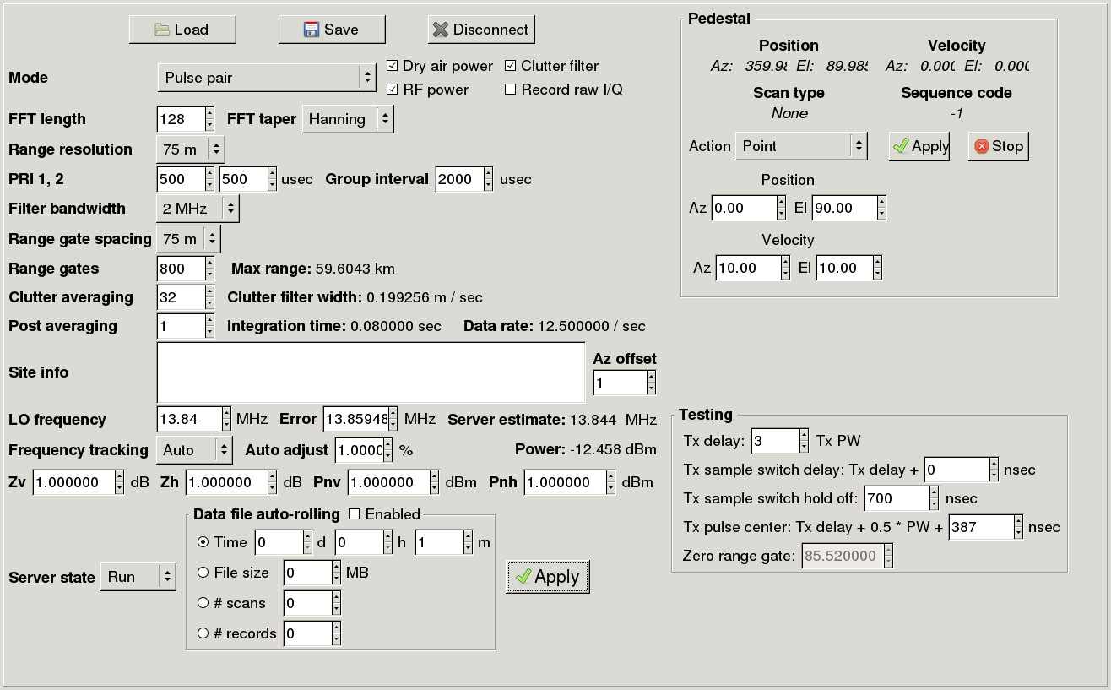

## Ensure safety radius

The radar has a 30 meter safety radius. This applies when the antenna is pointing below 10 degrees or so. Make sure no one is close to the radar before turning it on. We have a Web cam pointing at the radar at Marshall so you can check the safety radius. To view the camera, first open an xterm window and type in the following command, replacing <login> with your user login:

ssh -L 8080:192.168.99.101:80 <login>@cumulus

Then, open a Web browser and use the following for the address:

localhost:8080

## Start processes on xpol server

You are now ready to start the control processes on “xpol”. In your “xpol” window run:

start_all

This will start up the data acquisition and xpol control processes.

Also run:

start_RadMon.xpol

start_RadMon.xpol_raw

to monitor the FMQ data streams. It can take a little while before you see data in the RadMon windows. You will first see data in the xpol_raw window as the raw data starts to flow. The xpol window will only show data that is actually within our scan strategy.

If you want to see the beam-by-beam data, run:

start_HawkEye.xpol

## Disconnect from GUI

When finished with the start up, you need to disconnect from the GUI by clicking on the “Disconnect” button:



The button label will change to “Connect” when you are disconnected. At this point, you can exit from the control GUI. Multiple versions of this GUI can run at the same time so killing the GUI should save some confusion.

# Viewing Volume Data

The volume data can be viewed using either Jazz or CIDD. Jazz is the preferred method. To view the data using Jazz, open a browser window and use the following address:

<http://www.rap.ucar.edu/projects/xpol/jazz/xpol.jnlp>

This display can be used both behind and outside of the firewall.

If you can’t use Jazz for some reason and you know the ice login on vapor, you can use CIDD to view the volume data. This is discouraged because we want to be careful of the load on vapor, but it is available. To use CIDD, log into vapor as ice and run:

start_CIDD.xpol_vapor

# Stopping the Radar

When stopping the radar, you will again want to have xterm windows open on both “xpol” and “drx” and you will want to bring up the xpol control GUI. Instructions for opening these windows are given above.

## Connect to the xpold server

In the xpol control GUI, click “Connect” to connect to the xpold server:



When you are connected, the label for this button will change to “Disconnect”:



## Make sure the server is in run mode

Set “Server state” to “Run” and click “Apply”:

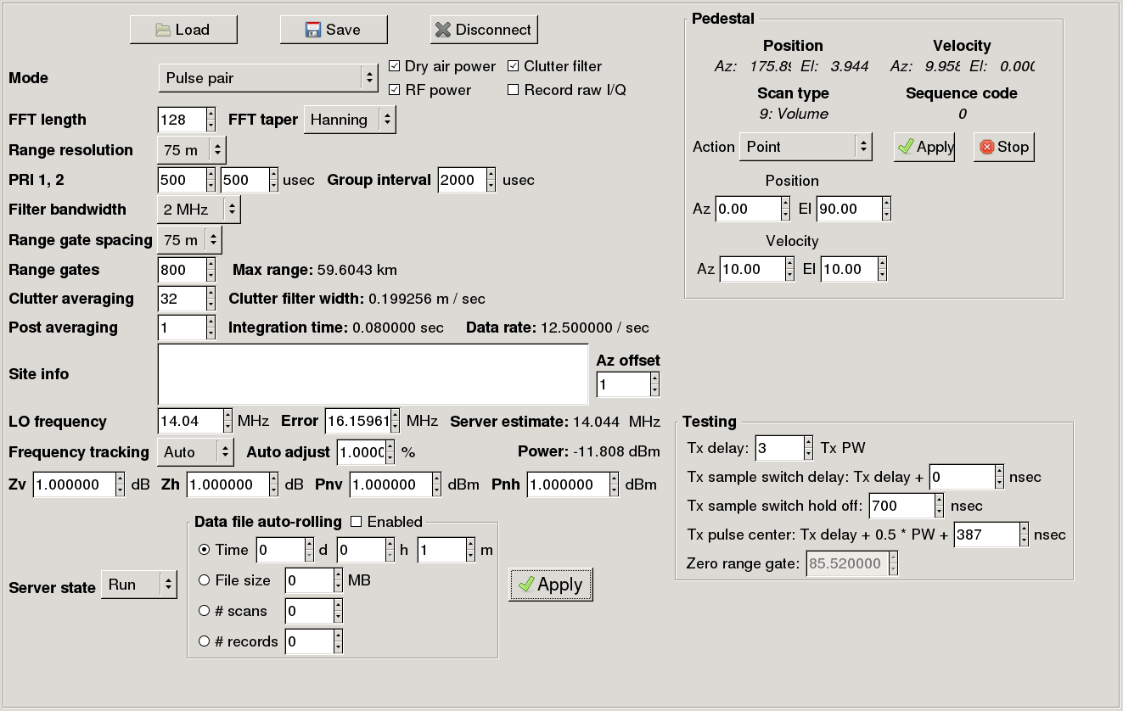

After clicking “Apply”, you will see a message saying that the server configuration is updating:

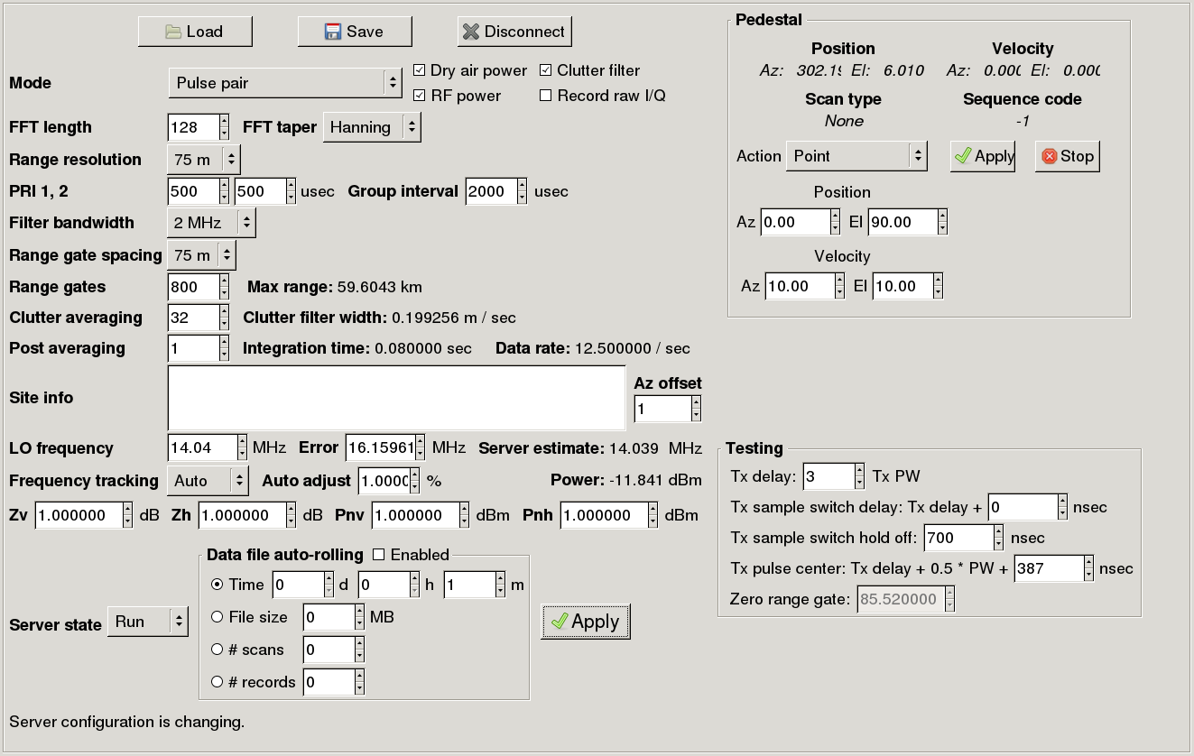

You need to wait for this status area to clear before continuing. This is true whenever you click the “Apply” button.

## Point the antenna vertically

Make sure the antenna is pointed vertically up so there is no radiation hazard. This is done in the “Pedestal” section of the GUI. Set the indicated values and click apply:

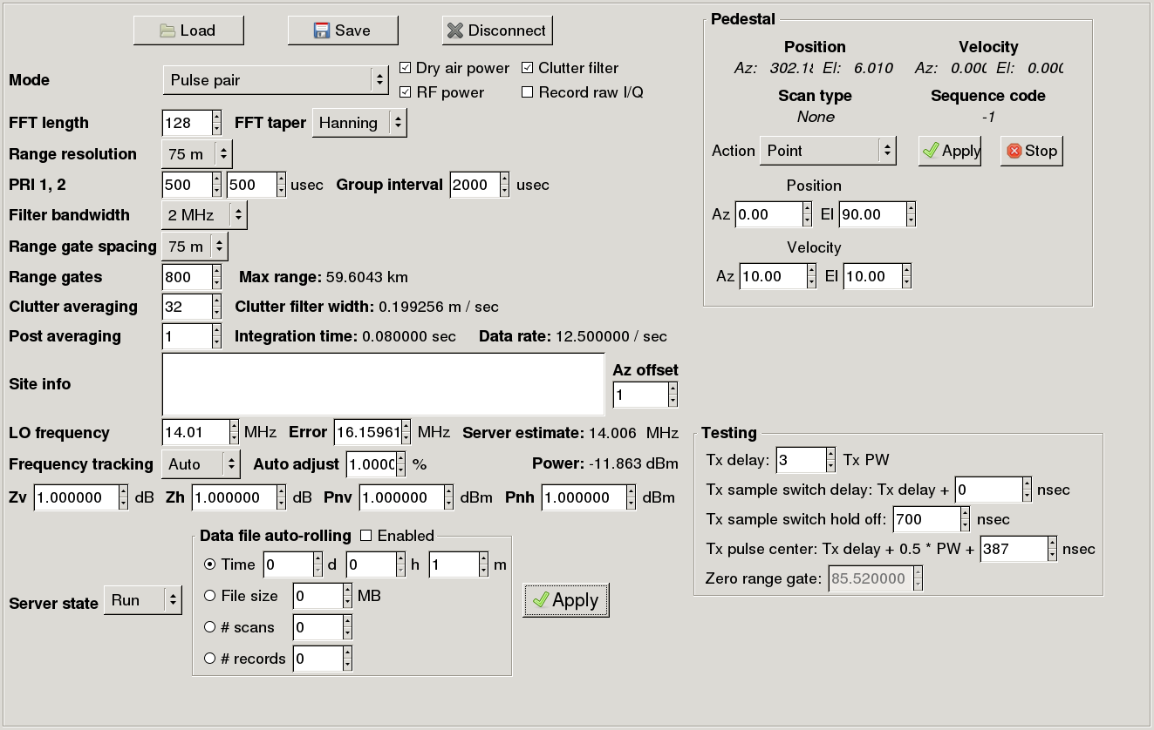

Make sure th elevation is close to 90 degrees, i.e. the antenna is pointing vertically, then click “Stop” to set the brakes:



## Turn off the transmitter

Set “Frequency tracking” to “Manual”, click on “RF power” to remove the check mark and click “Apply”:

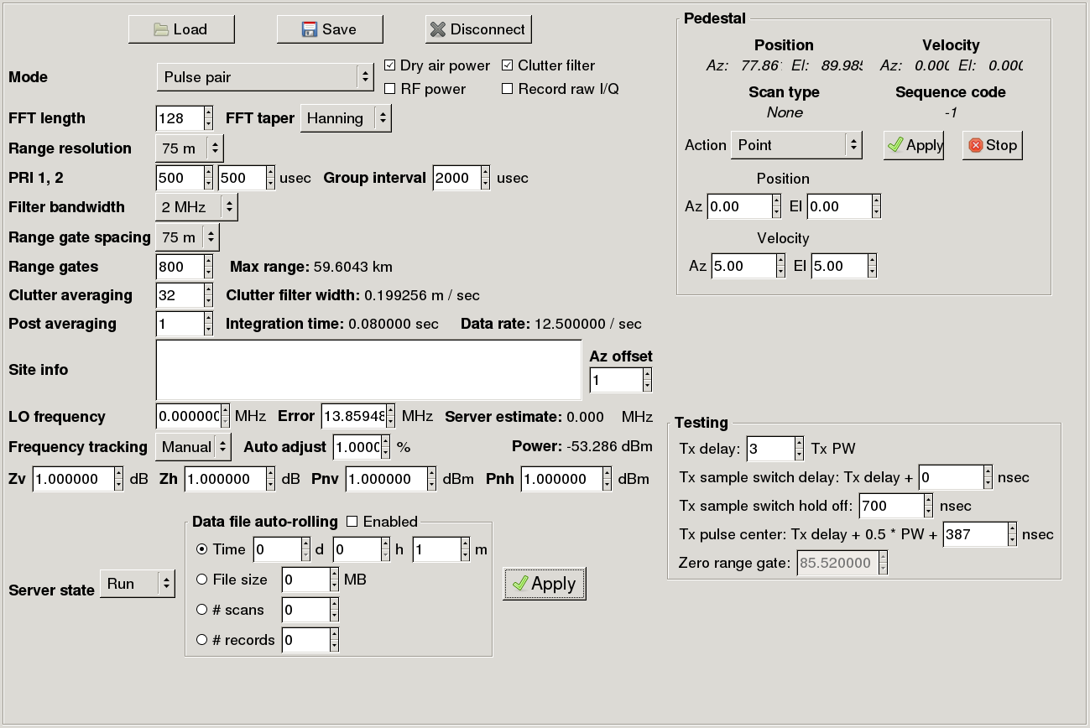

Monitor the “Power:” value:



This value starts around -12 dBm. The power should decrease to around -85 dBm or nan before continuing.

## Turn off dry air power

Click on “Dry air power” to remove the check mark then click “Apply”.

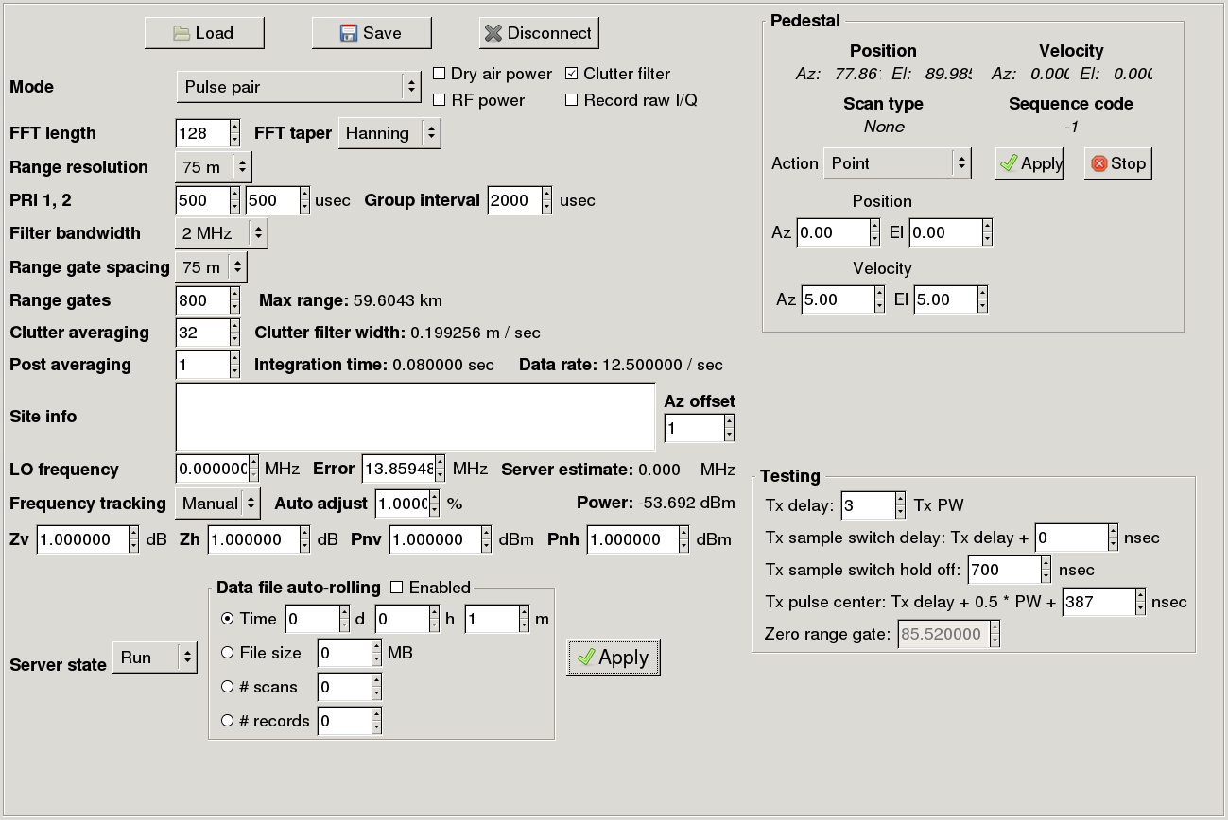

At this point, the radar should be stopped. To leave things in a clean state, set the “Server state” to “Idle” and click “Apply”.



Now you can disconnect the GUI and exit, as described above.

## Stop processes on xpol

Stop the processes on “xpol” by entering this command in your “xpol” window:

stop_all

Everything should now be stopped. You can close the xpol control GUI at this point.